European Union
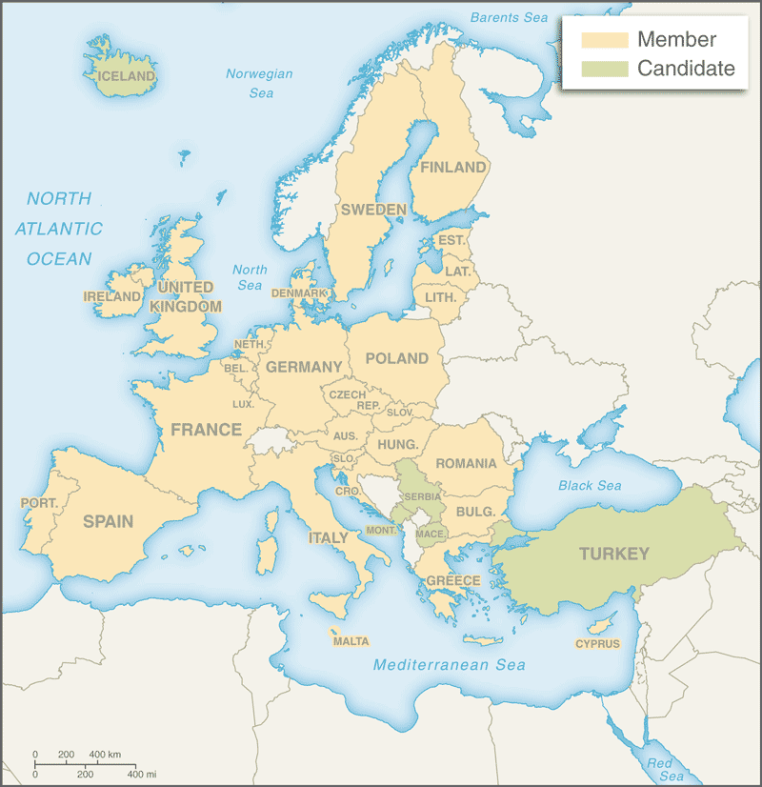 | Area 4,479,986 sq.km. 28 Countries Population 515 million  Catholic 48%, Protestant 16%, Orthodox 8%, Muslim 2%, Other 1%
 | Labor 234 million: Agriculture 5%, Industry 22%, Services 73%
GDP US$20 trillion, GDP Per capita $39,200, Growth 1.9% (2016)
GDP by sector: Agriculture 1.5%, Industry 24.4%, Services 74.1%
Exports US$1.9 billion: machinery, motor vehicles, aircraft, fuels, pharmaceuticals, plastic, iron & steel, furniture, alcoholic beverages
USA 17.1%, China 8.5%, Switzerland 7.8%, Russia 7.2%, Turkey 4.4%
Imports US1.7 billion: fuels, machinery, vehicles, pharmaceuticals,
other chemicals, gemstones, textiles, aircraft, plastics, metal, ships China 16.1%, USA 11.4%, Russia 11%, Switzerland 5.9%, Norway 4.3%
Following the two World Wars, far sighted European leaders sought a response to the desire for peace and reconciliation. In 1950, the French Foreign Minister proposed a pooling of the production of coal and steel in Western Europe and setting up an organization which would bring France and Germany together and be open to other countries joining. The following year, the European Coal and Steel Community (ECSC) was created when 6 members, Belgium, France, West Germany, Italy, Luxembourg and the Netherlands signed the Treaty of Paris. In 1957, the Treaties of Rome created the European Economic Community (EEC) and the European Atomic Energy Community (Euratom), and the six member states undertook to eliminate trade barriers by forming a common market. In 1967, all three community institutions merged into the European Community (EC) creating the European Parliament. In 1973, the first enlargement took place with the addition of Denmark, Ireland and the UK; the 1980’s saw further expansion with Greece joining in 1981 and Spain and Portugal in 1986.
The 1992 Treaty of Maastricht laid the basis for further cooperation in foreign and defense policy, in judicial and internal affairs, and in the creation of an economic and monetary union – including a common currency. This further integration created the European Union (EU), at the time standing alongside the EC. In 1995, Austria, Finland and Sweden joined the EU/EC. The Euro was launched on January 1st 1999 and it became the unit of exchange for all EU countries with the exception of Denmark, Sweden and the UK; in 2002, citizens of those 12 countries began using Euro banknotes. Ten new countries joined the EU in 2004 – Cyprus, the Czech Republic, Estonia, Hungry, Latvia, Lithuania, Malta, Poland, Slovakia, and Slovenia. Bulgaria and Romania joined in 2007 and Croatia in 2013, bringing the membership to 28. Seven of these new countries – Cyprus, Estonia, Latvia, Lithuania, Malta, Slovakia and Slovenia adopted the Euro, bringing the total Euro-zone membership to 19. After several earlier efforts at ensuring the EU could function efficiently, the Treaty of Lisbon was approved in December 2007, after which the process of national ratification began. The Lisbon Treaty came into force on December 1st 2009 and the EU officially replaced the EC.
Since 1977 in the UK, both pro- and anti-European views have had support at different times. In a referendum in 1975, two-thirds of British voters favored continued EC membership. In January 2013, Prime Minister David Cameron, under pressure from many of his MP’s and from the rise of UKIP, announced that a conservative government would hold an in-out referendum before the end of 2017 on a renegotiated UK/EU package. Cameron sought to renegotiate on four key points, protection of the single market for non-Eurozone countries, reduction of “red tape”, exempting Britain from “ever-closer union” and restricting EU immigration. Some limits to in-work benefits for new EU immigrants were indeed agreed, but required the permission from the European Commission and Council. Finally, frustrated by a remote bureaucracy in Brussels and massive migration into the country, UK citizens on June 23rd 2016 voted narrowly (51.9%) to leave the EU. The so-called “Brexit” will take years to carry out, but could embolden skeptics of EU membership in other member states.

