Finland

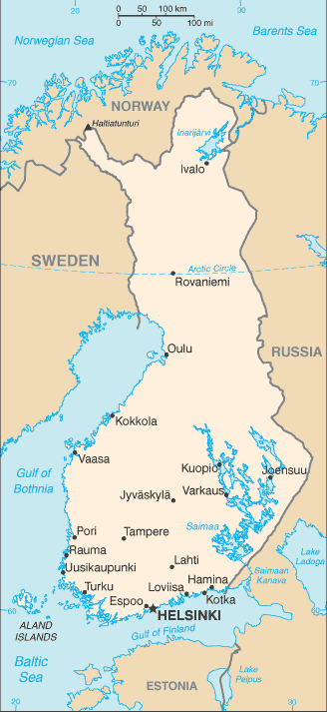 | Area 338,145 sq.km. Population 5.5 million; ethnicity - Finns 93.4%, Swede 5.6%, Russian 0.5%, Estonian 0.3% ; Languages - Finish 87.9%, Swedish 5.2%, Russian 1.4%  Religions - Lutheran 70.9%, Greek Orthodox 1.1% - unspecified 28%
 | Labor Force 2.4 million - Agriculture 4%, Industry 21%, Services 75%
GDP US$ 245 billion, Per capita $44,5000, Growth 2.8% (2017)
GDP by sector - Agriculture 2.7%, Industry 28.2%, Services 69.1%
Exports US$68 Billion: electrical & optical equipment, transport equipment, machinery, pulp/paper, chemicals, basic metals, timber
Key partners: Germany 14%, Sweden 10%, US 7%, Netherlands 7%. China 6%, Russia 6%
Imports US$65 billion: foodstuffs, petroleum products, chemicals, transport equipment, iron & steel, machinery, computers, electronics, textiles and fabrics, grains
 | Key partners – Germany 18%, Sweden 16%, Russia 13%, Netherlands 9%

The area that is now Finland was settled around 8,500 BCE, inhabited by hunter gatherers. In the bronze age cultivation and animal husbandry spread, slowed by the cold climate; in the iron age population and cultural/commercial contacts to the Baltics and Scandinavia grew. The common Finnic Language was spoken around the Gulf of Finland 2000 years ago. As a result of the crusades and the colonization of some Finish coastal areas with Catholic Swedish population, Finland gradually became part of the Kingdom of Sweden and Swedish became the language of the nobility, administration and education. During the protestant reformation, the Finns gradually converted to Lutheranism. In the 18th century, wars between Sweden and Russia twice led to the occupation of Sweden by Russian forces, times known as the Greater Wrath (1714-1721) and the Lesser Wrath (1742-1743). In March 1809, Finland became an autonomous Grand Duchy in the Russian Empire and in 1811, Alexander I incorporated Russian Vyborg province into the Grand Duchy. During the Russian era, the Finnish language began to gain recognition and achieved equal legal status with Swedish in 1892. In 1906, universal suffrage was adopted in the Grand Duchy and the relationship between the Grand Duchy and the Russian Empire soured and desire for independence gained ground and the right-wing government declared independence on December 6th 1917. In 1918 there was a brief but bitter civil war between the “Whites” (in Northern Finland) and the “Reds” (in the South); deep social and political enmity was sown between the Whites and the Reds and would last until the Winter War of 1939-40. Finland aligned with Germany following the German invasion of the Soviet Union and aided in the siege of Leningrad. After resisting a major Soviet offensive in in June/July 1944, Finland reached an armistice with Soviet Union. Treaties signed in 1947/48 resulted in Finland ceding most of Finnish Karelia, Salla, and Petsamo amounting to 10% of its land area and 20% of its industrial capacity including the port of Vyborg. Officially claiming to be neutral, Finland lay in the grey zone between the Western Countries and the Soviet Union, but in spite of significant Soviet influence, Finland maintained a market economy.

The economy of Finland has a per capita output equal to that of other major European countries. Finland has significant timber, mineral (iron, copper, nickel, gold) and freshwater resources. The greater Helsinki area generates around one third of Finland’s GDP, with particular emphasis on high technology manufacturing. Finland is highly integrated into the global economy and international trade produces one third of the GDP. In spite of the harsh climate, Finland’s agriculture has been highly efficient and productive, especially when compared with farming in other European countries. Forests play a key role in the country’s economy, making it one of the world’s leading wood producers and providing raw materials at competitive prices. So we have a country of great diversity - from lumber, agriculture and mining to high technology (Nokia included of course).

