Jordan
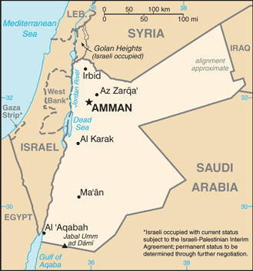 | Area 89,342 sq.km, Population 10.5 million Jordanian 69.3%, Syrian 13.3%  Palestinian 6.7%, Egyptian 6.7% - other 4%; Languages: Arabic and English.  Muslim 97.2% majority Sunni, Christian 2.2% majority Greek Orthodox.
 | Labor 2.3 million: Agriculture 8%, Industry 20%, Services 72%
GDP US$89 billion, GDP Per capita $9,200, Growth 2% (2017)
GDP by sector: Agriculture 4.5%, Industry 28.8%, Services 66.7%
Exports US$7.5 billion: textiles, fertilizer, potash, phosphates, vegetables
Partners: US 24.9%, Saudi Arabia 12,8%, India 8.2%, Iraq 8.2%, Kuwait 5.4%
Imports $18.2 billion: crude oil, refined petroleum, machinery, iron. Partners: China 14%, Saudi Arabia 14%, US 10%, UAE 5%, Germany 4%
What is now Jordan has been inhabited since the Paleolithic period; over the ages it was ruled by the Nabataean Kingdom, the Roman Empire, and the Ottoman Empire. After the Great Arab Revolt against the Ottomans in 1916 during World War I, and the dissolution of the Ottoman Empire, The League of Nations awarded Britain the mandate to govern much of the Middle East. Britain demarcated a semi-autonomous region of Transjordan from Palestine in the early 1920’s. The area gained its independence in 1946 and thereafter became The Hashemite Kingdom of Jordan. The country’s long-time ruler, King Hussein (1953-99), successfully navigated competing pressures from the major powers (US USSR, and UK), various Arab States, Israel, and large internal Palestinian population. Jordan lost the West Bank to Israel in the 1967 Six-Day War. King Hussein in 1988 permanently relinquished Jordanian claims to the West Bank; in 1994 he signed a peace treaty with Israel. King Abdallah II, King Hussein’s eldest son, assumed the throne following his father’s death in 1999. He has implemented modest political reforms, including the passage of a new electoral law in early 2016 and significant economic liberalization and reforms to promote growth. In 2016, the Islamic Action Front, which is the pollical arm of the Jordanian Muslim Brotherhood, returned to parliament with 15 seats after having boycotted the previous two elections in 2010 and 2013. Jordan is a founding member of the Arab League and the Organization of Islamic Co-operation.

Jordan is a relatively small, semi-arid, almost landlocked country. Jordan has been repeatedly referred to as an “oasis of stability” in a turbulent region; it has been mostly unscathed by the violence that swept the region following the Arab Spring in 2010. From as early as 1948, Jordan has accepted refugees from multiple neighboring countries in conflict. An estimated 2.1 million Palestinian and 1.4 million Syrian refuges are present in Jordan as of the 2015 census. The kingdom is also a refuge to thousands of Iraqi Christians. While Jordon continues to accept refugees, the recent large influx from Syria placed a substantial strain on national resources and infrastructure.

Jordan is classified as a country of “high human development” with an “upper middle income” economy. The Jordanian economy, one of the smallest economies in the region, is attractive to foreign investors based upon a skilled workforce. Jordan’s economy is relatively well diversified. Trade and finance combined account for nearly one third of GDP; transportation and communications, public utilities, and construction account for one fifth, and mining and manufacturing constitute nearly another fifth. Despite plans to expand the private sector, the State remains the predominant force in Jordan’s economy. The country is a major tourist destination, also attracting “medical tourism” due to its well-developed health sector.

