Norway
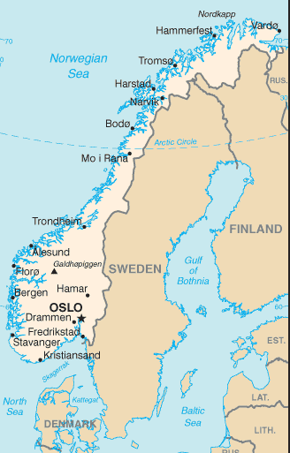 | Area 323,802 sq.km, Population 5.3 million, Norwegian 94.4%, other EU 3.6%  Church of Norway 82.1%, Catholic 1.8%, other Christian 3.9%, Muslim 2.3%  Languages – Norwegian (Bokmal & Nynorsk), Sami & Finish speaking minorities
 | Labor 2.8 million: Agriculture 2.1%, Industry 19.3%, Services 78.6%
GDP US$364.5 billion, GDP Per capita $69,400, Growth 1.1% (2016)
GDP by sector: Agriculture 2.5%, Industry 31.7%, Services 65.8%
 | Exports US$89 billion: commodities, petroleum and petroleum products – machinery, chemicals, metals, foodstuffs - UK 21%, Germany 14.4%, Netherlands 10.7%, France 6.9%, Sweden 6.5%, Belgium 4.4%, US 4.3%, Denmark 4%
 | Imports US$74 billion: commodities, machinery and equipment, chemicals, metals, foodstuffs - Germany 12.2%, Sweden 12.2% China 11.2%, US 6.6%, Denmark 5.7% , UK 5.2%, Netherlands 4.1%
With the retreat of the ice sheets around 10,000 BC, the earliest inhabitants of what is now Norway moved steadily northwards along the coastal areas, fishing and hunting. Between 5,000 and 4,000 BC the earliest agricultural settlements appeared around Oslofjord and by 400 BC had spread to southern areas. In the late 8th century, Norwegians expanded across the seas to the British Isles and later Iceland, Greenland and Labrador. The Viking age saw the unification of the country and the adoption of Christianity in 994; Bergen became the main trading port, controlled by the Hanseatic League. In 1397 Norway entered the Kalmar union with Denmark and Sweden – Sweden left the union in 1523, while Norway remained until 1814. Sweden then invaded Norway, but agreed to let Norway keep its own constitution in return for accepting the union under a Swedish king. Rising nationalism throughout the 19th century led to a 1905 referendum granting Norway independence. Although Norway remained neutral in World War I, it suffered heavy losses to its shipping. Norway proclaimed its neutrality at the outset of World War II, but was nonetheless occupied for 5 years by Nazi Germany. In 1949 Norway abandoned neutrality and became part of NATO.
By referendums in 1972 and in 1994, Norway rejected proposals to join the European Union. However, Norway, together with Iceland and Liechtenstein, participate in the European Union’s single market through the European Economic Areas (EEA) agreement. Norway is a highly integrated member of most sectors of the EU internal market; some sectors, such as agriculture, oil and fish, are not so. Norway also acceded to the Schengen Agreement allowing border free movement among those European countries who also joined.
Norway is richly endowed with natural resources including petroleum (discovered in the late 1960’s), hydropower, fish, forest and minerals, which have led it to obtaining one of the highest standards of living in the world. Norwegians today enjoy the second-highest GDP per-capita amongst European countries (after Luxembourg) and have the 6th highest GDP per-capita in the world. Norway maintained first place in the world in the UNDP Human Development index for six years from 2001 to 2006 and reclaimed this position in 2009 through 2015. Norway is judged to be the world’s most well-functioning and stable country.
Norway is an example of a “mixed economy”, a prosperous capitalist welfare state and social democracy, featuring a combination of free market activity and large state ownership in certain key sectors. Public heath care in Norway is free (after an annual charge of 2000 krona – $167 – for those over 16) and parents have 46 weeks of paid parental leave. Norway has an unemployment rate of 4.8%, with 68% of the population aged 15 to 74 employed; 9.5% of the population 18-66 receive a disability pension; and 30% of the labor force is employed by the government, the highest in the OECD. The hourly productivity levels, as well as the average hourly wages, are among the highest in the world.

