Romania

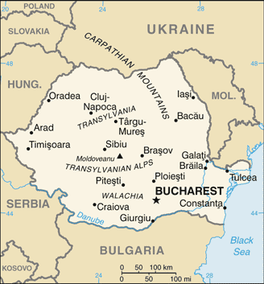 | Area 238,000 sq.km. Population 21.6 million. Ethnic Groups: Romanians 83.4%, Hungarian 6.1%, Roma 3.1%, Other 7.4%.  Eastern Orthodox 81.9%, Protestant 6.4%, Roman Catholic 4.3%
 | Labor 9.1 million: Agriculture 28%, Industry 29%, Services 43%
GDP US$441 billion, GDP Per capita $22,300, Growth 5% (2016)
GDP by sector: Agriculture 3.3%, Industry 35.4%, Services 61.3%
 | Exports US$56 billion: commodities, machinery and equipment, agricultural products & foodstuffs, metals & metal products. Partners: Germany 20%, Italy 13%, France 7%, Hungary 5%, UK 4%
Imports US$66 billion: commodities, machinery and equipment, chemicals, agricultural products, fuels, minerals, metal products.
Key partners: Germany 20%, Italy 11%, Hungary 8%, France 6%, Poland 5%,China 5%, Netherlands 4%
The principalities of Wallachia and Moldovia, for centuries under the suzerainty of the Turkish Ottoman Empire, secured their autonomy in 1856; they were de facto linked in 1859 and formally united in 1862 under the new name Romania. The country gained recognition of its independence in 1878. It joined the Allied Powers in World War I and acquired new territories, most notably Transylvania, following the conflict. In 1940, Romania allied with the Axis Powers and participated in the 1941 German invasion of the USSR. Three years later, overrun by the Soviets, Romania signed an armistice. The post-war Soviet occupation led to the formation of a communist “people’s republic” in 1947 and the abdication of the king. The decades-long rule of dictator Nicolae Ceausescu, who took power in 1965, and his Securitate police state became increasingly oppressive and draconian through the 1980’s. Ceausescu was overthrown and executed in late 1989. Former communists dominated the government until 1996 when they were swept from power. Romania joined NATO in 2004 and the EU in 2007.
Romania is governed on the basis of a multi-party democratic system and the separation of powers between the legislative, executive and judicial branches. It is a semi-presidential republic where executive functions are held by both government and president. The president is elected by popular vote for a maximum of two terms of five years and appoints the prime minister, who then appoints the Council of Ministers. The legislative branch of the government known as the Parliament consists of two chambers, Senate and Chamber of Deputies whose members are elected every four years by simple plurality.
Romania began transition from communism in 1989 with a largely obsolete industrial base and a pattern of output unsuited to the country’s needs. Romania’s macroeconomic gains have only recently started to spur the creation of middle class. In spite of signing a $26 billion emergency assistance package in the aftermath of the global financial crisis, the GDP contracted until 2011; Romania and the IMF/EU/World Bank signed a 24-month standby agreement worth $5.6 billion, to promote fiscal discipline, encourage progress on structural reforms, and strengthen financial stability; no funds were drawn. In 2013 the participants agreed to a follow-on standby agreement worth $6.4 billion, again no funds were drawn.
Economic growth rebounded in 2013-2015, driven by strong industrial exports and excellent agricultural harvests, and the fiscal deficit was reduced substantially. Exports remain an engine of economic growth, led by trade with the EU, which accounts for roughly 70% of Romania trade. Domestic demand was a second driver due to the mid-2015 cut from 24% to 9% VAT levied on foodstuffs. In 2015, the government of Romania succeeded in meeting its annual target for the budget deficit and the external deficit remained low.

